Practical No.05
Configuring a Zone-Based Policy Firewall
Network:
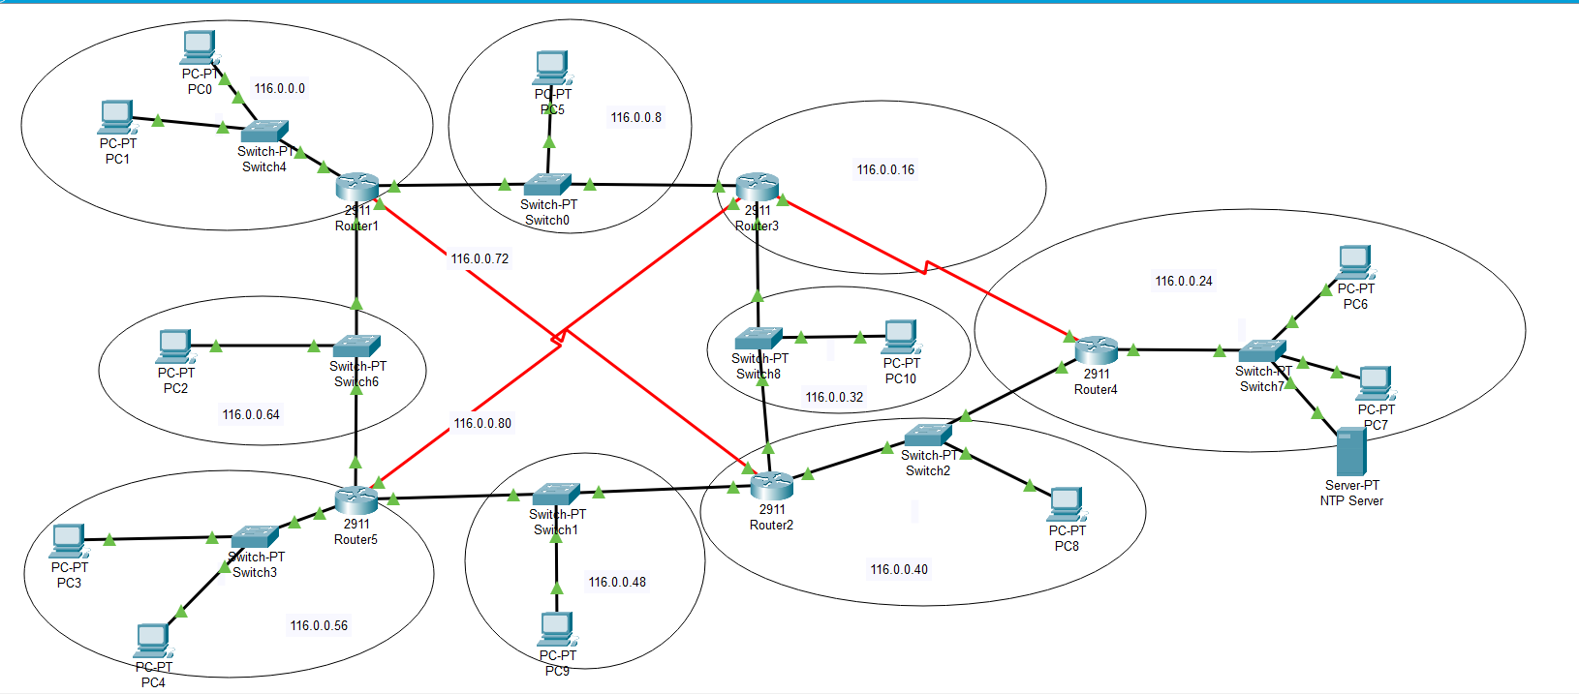

Ssh configuration on router4
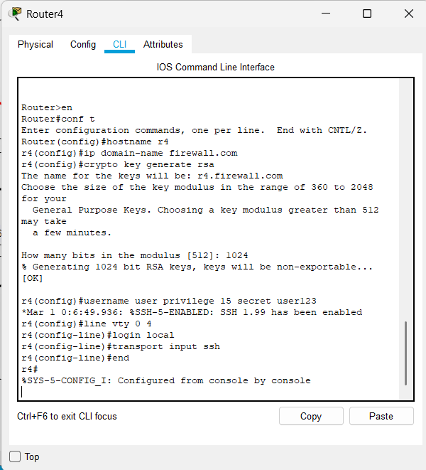

Installing the securityK9 package on router4
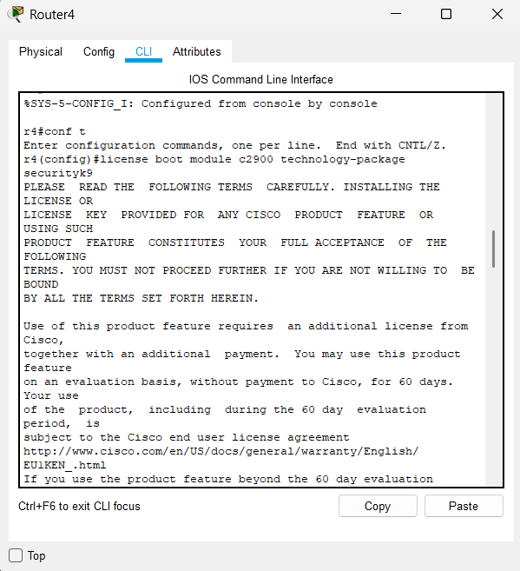

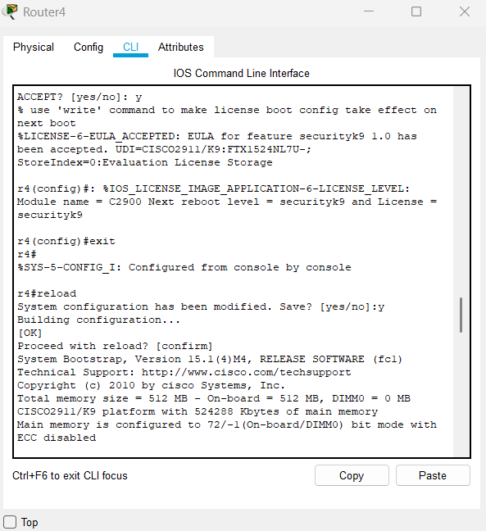

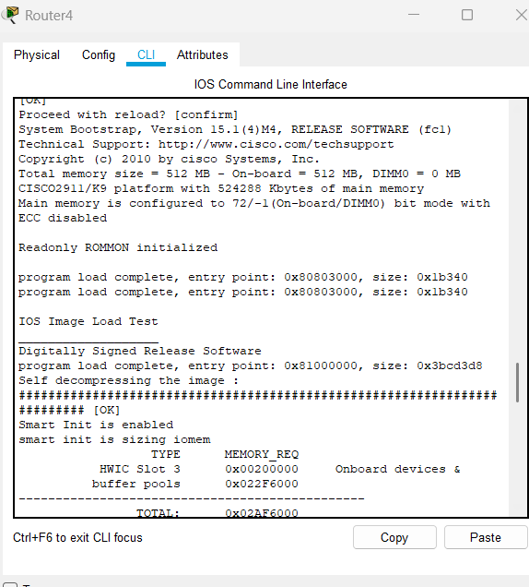

Creating zones for each network.
Router4 has 4 interfaces and for each interface Zone is created with different policies
ZONE-32 denies the icmp(ping) in a network
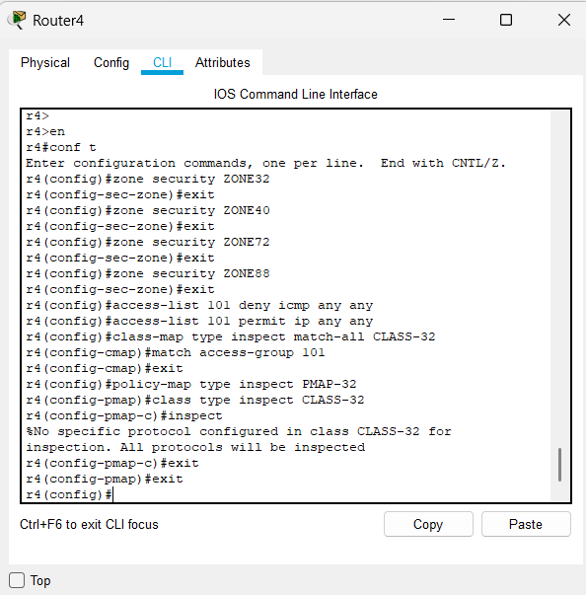

ZONE40 denies the HTTP and FTP service in a network
ZONE72 denies only FTP service in a network
ZONE80 denies the Ssh service in a network
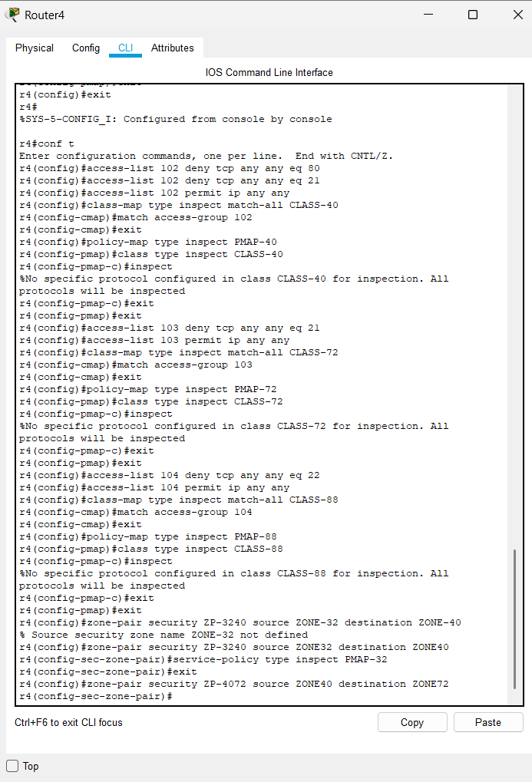
Assigning the zones to the interface

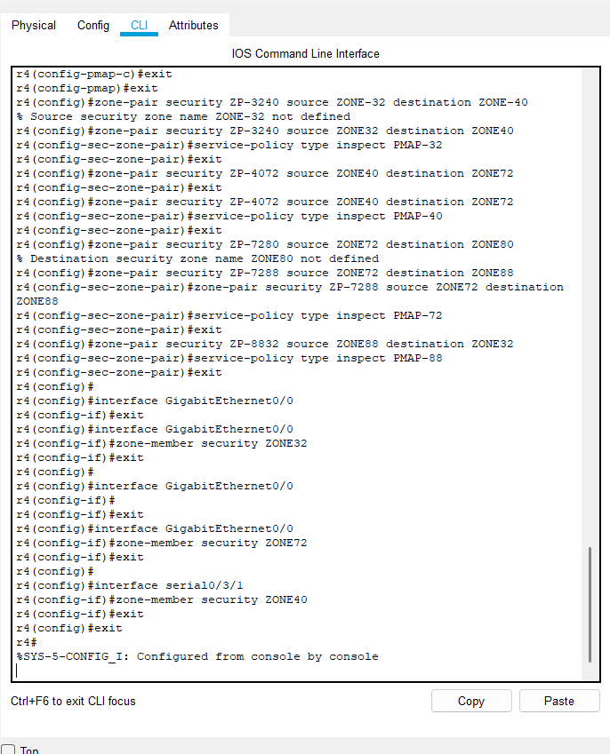ii

All the policies that are applied on each interface
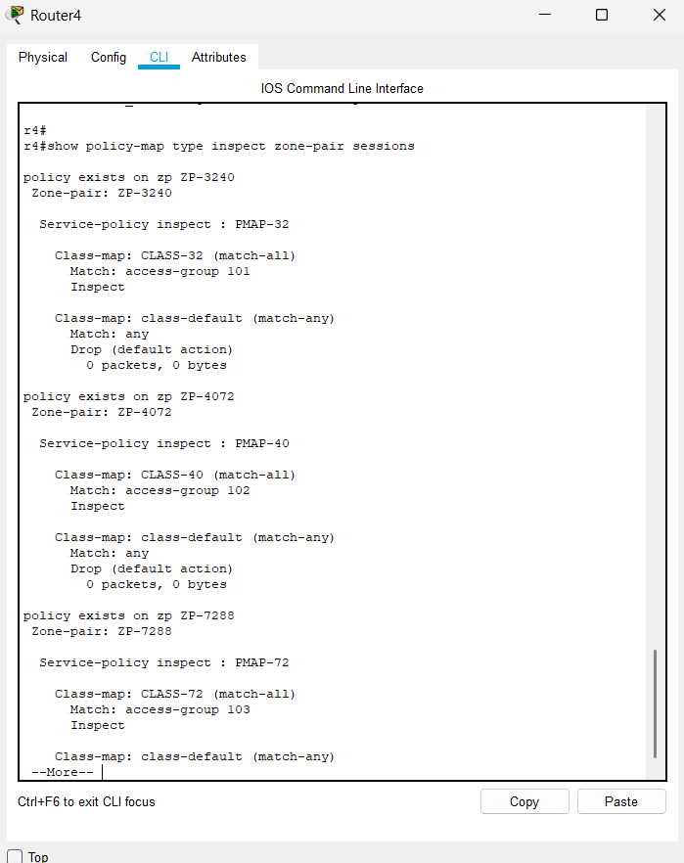
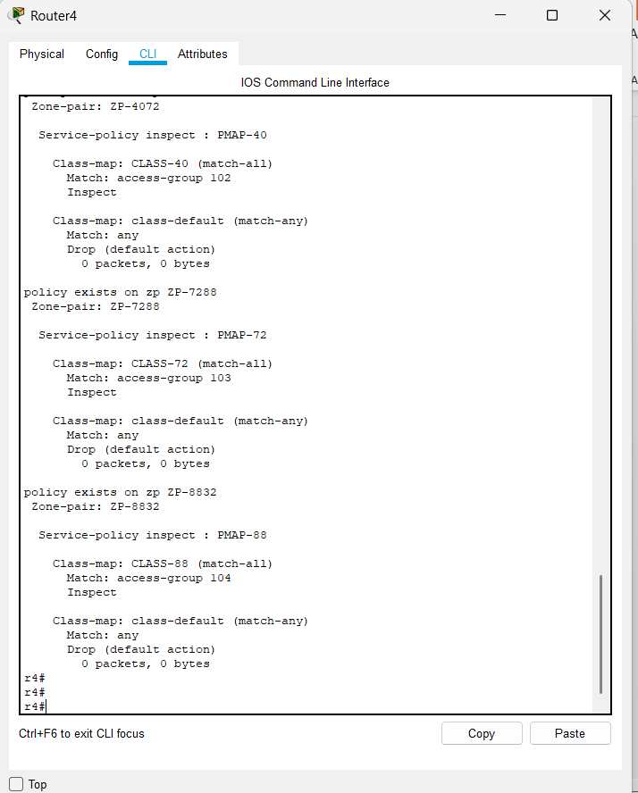
Zone32 policies
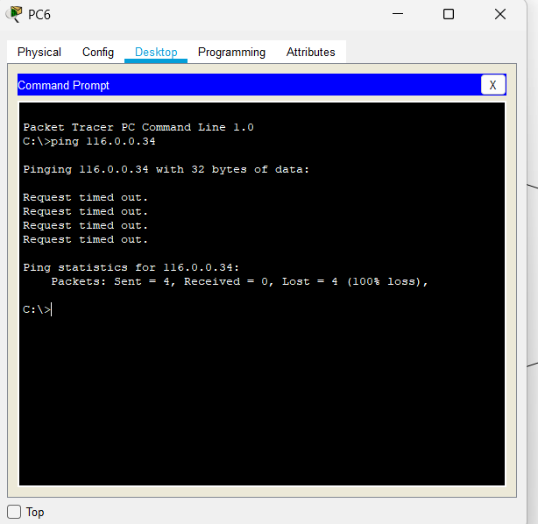
Zone40 policies
Denied the HTTP service
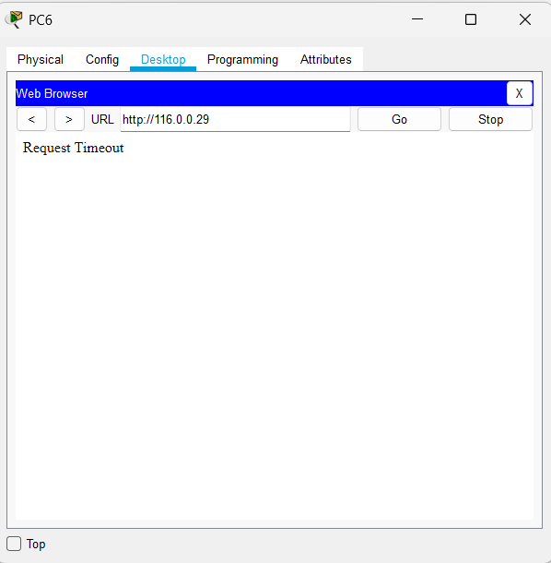
Denied the FTP service from server
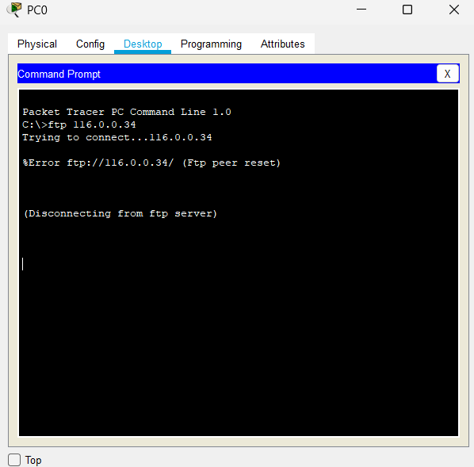
ZONE72
Denied the FTP service from server
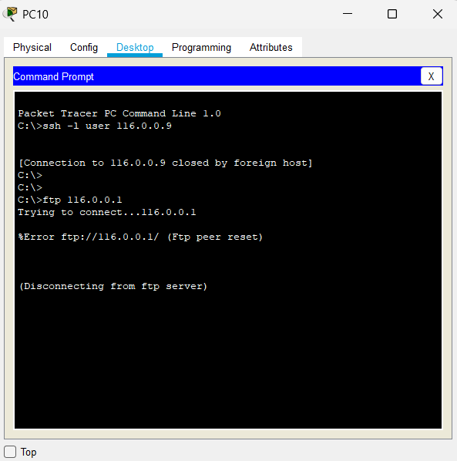
Zone88
Denied the ssh service

